HT600 Flagship 6.0" Industrial PDA Barcode Scanner
Power Without Limits | Android 13 | IP68 Ultimate Protection
Product Overview
HT600 is a flagship intelligent industrial terminal created by LQYCIT. It is not only a scanning device, but also a mobile high-performance data center. By perfectly integrating 2.0GHz eight core processing power, Android 13 security, and IP68 military grade protection, the HT600 is designed to solve complex challenges in modern logistics, precision warehousing, and extreme outdoor operations.
Whether it's field surveys under strong light or high-intensity cold chain logistics, the HT600 can easily achieve enterprise digital transformation with lightning fast response speed and all-weather endurance performance.
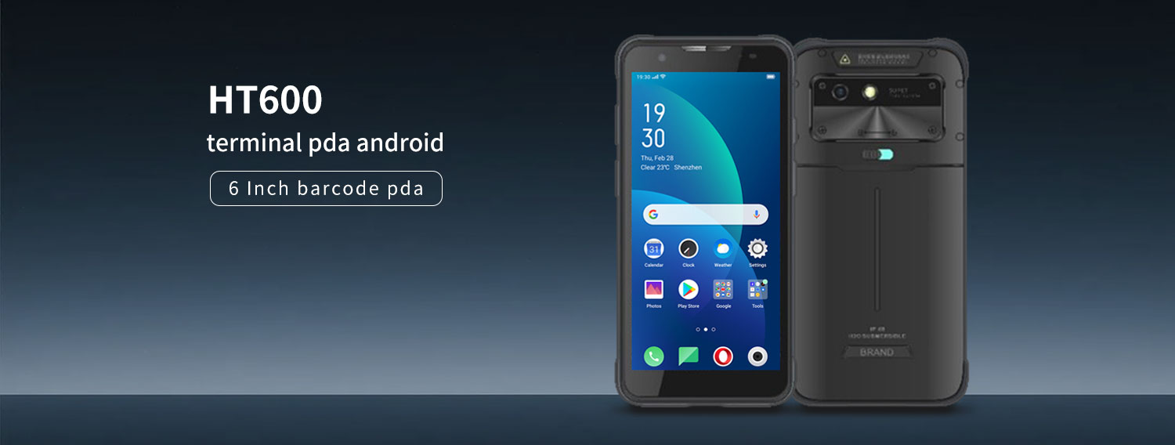
Category key parameters
Performance/System 8-core 2.0GHz/Android 13/4G+64G
Display screen 6.0 "FHD+/high brightness/industrial grade touch control
Professional 1D/2D image scanning engine with scanning ability (supporting dirt/reflective codes)
Battery/Rechargeable 8000mAh (detachable)/Supports RTC non-stop battery swapping
Protection level IP68 (dustproof and waterproof)/industrial grade anti drop
Wireless connection 4G full network/dual band WiFi/BT 5.0/NFC
16MP rear camera (PDAF)/5MP front camera (optional)

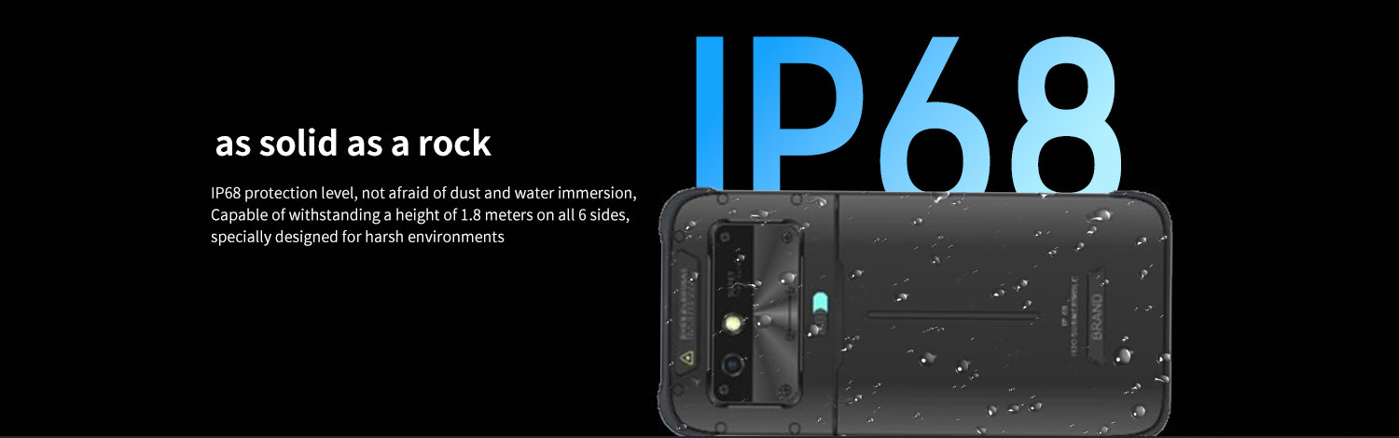Core Highlights: Competitive Advantage
1. Peak performance: Smooth office like silk
• Excellent computing power: Equipped with an 8-core 2.0GHz high-performance processor. When running large-scale WMS (Warehouse Management System) or ERP software, it displays a "hundred meter sprint" level speed rather than a strenuous long run.
Advanced system: Native support for Android 13. Not only does it bring a smoother interactive experience, but it also reaches new heights in enterprise level data privacy and application compatibility.
• Large storage: 4G+64G standard configuration, capable of handling real-time processing of massive inventory data with ease.
2. Visual feast: 6-inch FHD+high brightness large screen
Outdoor visibility: equipped with a 6.0-inch FHD+high-definition display screen. Industrial grade high brightness design ensures that you can read reports clearly even under strong midday sunlight, bidding farewell to the embarrassment of squinting for data.
• Detail capture: Rear 16 megapixel autofocus camera. Whether it is the evidence collection of damaged goods or the records of equipment inspections, high-definition image quality can be presented.
3. Rock like strength: fearless of any harsh working conditions
IP68 highest rating: This is not only waterproof, but also provides all-round sealing. It can completely isolate dust and can continue to work normally in water at a certain depth.
Anti drop design: Passed rigorous industrial grade drop testing. In busy warehouses, damp outdoor environments, or dusty factories, HT600 always remains "online", greatly reducing equipment maintenance and replacement costs.
4. "Unlimited" battery life: 8000mAh massive battery
• Ultra long standby: Built in 8000mAh detachable large capacity battery, supports 18W fast charging.
• Uninterrupted operation: Supports RTC battery hot replacement. This means that you don't need to shut down when replacing the main battery, ensuring uninterrupted business logic and truly achieving seamless handover 24/7.
5. Precise collection: perfect combination of scanning and NFC
Professional barcode scanning engine: Whether facing stains, reflections, or distant barcodes, it can achieve "one scan and get it".
Full featured NFC: Integrated with a 13.56MHz module, it perfectly supports near-field recognition of employee attendance cards, membership cards, and various smart tags.
Industry Applications
• Logistics delivery: fast scanning of codes, signing and taking photos, and identification of waybills.
Intelligent warehousing: high-frequency inventory, inbound and outbound management, big data storage.
Medical and health services: mobile ward rounds, drug traceability, asset management.
Public utilities: power inspection, parking fees, government law enforcement, on-site evidence collection.

Basic Information
processor | 8-core 2.0GHz high-performance processor
operating system | Android 13
Memory(RAM+ROM) | 4GB+64GB (optional 6G+128GB)
expand memory | Micro SD card, supports up to 256GB
display screen | 6-inch IPS display screen resolution 720 * 1440, optional 2160X1080P
touch screen | Multi touch, can be operated with water on the screen or wearing gloves
rear camera | 1600W pixel high-definition camera, supporting autofocus and flash
front camera | 500W pixel camera (optional)
audio | Speaker (mono), microphone x 2, earpiece
prompt | Vibration prompt/LED prompt/audio prompt
keyboard | Silicone buttons: power button, volume+/- button, scan button x 2
booth | Nano SIM card x1/PSM card x1 (TF card)
battery | Rechargeable polymer battery (standard 3.8V 8000mAh) (low temperature -30 ℃ 7600mAh) (low temperature -40 ℃ 7000 mAh)  Standby time>350 hours  Working hours>12 hours (depending on the usage environment)  Supports fast charging, detachable battery, and supports replacing RTC battery without shutting down  Charging time<3 hours (using standard fast charging power adapter and data cable)
sensor | Light proximity sensor, distance sensor, gravity sensor  Optional: gyroscope, electronic compass
Communication transmission
USB port | Type-C USB x 1, Support OTG function
WLAN function | Dual band 2.4GHZ/5Ghz, supporting IEEE 802 a/b/g/n/ac protocols
Bluetooth | Supports BT 5.0, with a transmission distance of 5-10 meters
GPS | Supports GPS, Galileo, Glonass, Beidou
Wireless Wide Area Network | 2G: GSM (Mobile/Unicom), CDMA (Telecom)  3G: WCDMA (China Unicom), CDMA 2000 (China Telecom), TD-SCDMA (China Mobile)  4G: TD-LTE (Mobile), FDD-LTE (China Unicom, China Telecom)
Optional configuration
2D scanning engine | Soft solution: MD5066/Honeywell N5703/CM60  Hard solution: N660
Support 2D barcode type | PDF417,Micro PDF417,GS1 Composite,Aztec Code,Data Matrix,QR Code,Micro QR Code,  MaxiCode,Hanxin Code,etc.
Optional configuration
NFC | Working frequency: 13.56MHz  Protocol standards: Supports ISO14443A/B and 15693 protocols
Low frequency RFID (optional) | Support, 125K (distance 3-5cm)/134.2K (distance 10-17cm)
environmental parameters
Operating Temperature | -30 ℃ to 60 ℃  *For safety reasons, please do not charge in low temperature environments
Storage temperature | -40 ℃ to 70 ℃
humidity | 5% RH -95% RH (no condensation)
drop specification | Within the operating temperature range, all six sides can withstand a height of 1.8 meters  30 impacts of falling onto marble floors
Protection level | IP68
Development support
development language | Java
Develop API | Android Standard Interface
structural parameters
Size (mm) | 169.5mm×83.2mm×18.2mm
weight | <350g (Depending on the device's functional configuration)
Equipment accessories
standard configuration | Adapter, data cable, protective film, instruction manual, hand rope
optional | charging dock

